**Sullivan Middle School**

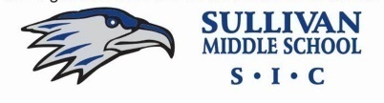

**School Improvement Council**

**Zoom**

***Tuesday, May 18th, 2021***

***5:30 to 6:30 p.m.***

1. Welcome (1)

2. Approval of Minutes (1)

3. Principal’s Report (15)

4. Committee Reports

a. Report to the Parents any feedback?- (3)

b. Health & Wellness Goals- Any goals for next year-Group (5)

c. Riley Award status- Kelly (1)

d. Elect Board for 2021-22 – Kelly (2)

Chair, Vice Chair, Secretary

Two teachers roll off- Need two more elected teachers in 2021-22

5. Goals: Discuss next year goals, either same or same and new-(10)

a. Parent & School Climate Satisfaction

*Building parent community & confidence goal for 2021-22

b. Teacher & Staff Climate Satisfaction

c. Continued growth in Academic Achievement

6. Comments-question about how school will address racism, esp Asian hate that could occur. Review actions/policies, ie. Handbook for this happening or to prevent.

7. Review assignments and agenda for next meeting (5)

8. Adjourn

*Next Meeting: TBA in August 2021*